ITA0502 COMPUTER VISION – SLOT C
RAILWAY TRACK MONITORING SYSTEM
1.RAILWAY TRACK MONITORING SYSTEM-WRITE UP
The proposed Railway Track Monitoring System is a real-time computer vision system that uses cameras mounted on inspection vehicles to monitor railway tracks. It automatically detects cracks, broken components, surface defects, and abnormal objects. The system aims to achieve at least 92% detection accuracy, 15 FPS processing speed, latency of not more than 100 ms per frame, and a false-positive rate of not more than 5%. It should also work reliably under difficult conditions such as vibration, motion blur, poor lighting, shadows, rust, weather changes, and complex backgrounds. To identify the most suitable approach, five methods—Edge and Hough Transform, SIFT, Viola–Jones, YOLO, and Deep Learning—will be compared based on accuracy, latency, processing speed, computational requirements, and robustness.
Edge and Hough achieves 88% accuracy, SIFT achieves 90%, and Viola–Jones achieves 84%, so they fail the required accuracy. Deep Learning achieves 97% accuracy but has a high latency of 130 ms/frame. Therefore, YOLO is selected as the best approach, providing 94% accuracy, 85 ms latency, and moderate computation. OpenCV preprocessing can also be combined with YOLO to improve efficiency and robustness.
The system will use Python, OpenCV, YOLO, SIFT, Viola–Jones, NumPy, Matplotlib, a railway dataset, and an edge computing device for implementation and testing. However, performance may decrease due to vibration, motion blur, poor lighting, shadows, rust, weather, occlusion, and complex backgrounds. The accuracy and false-positive rate depend on the quality and diversity of the dataset. YOLO may also require optimization to maintain 15 FPS on an edge device. Therefore, the actual performance must be experimentally verified, and extensive testing is required before real-world railway deployment.

2.Pseudocode – Railway Track Monitoring System
Video Input & Initialization
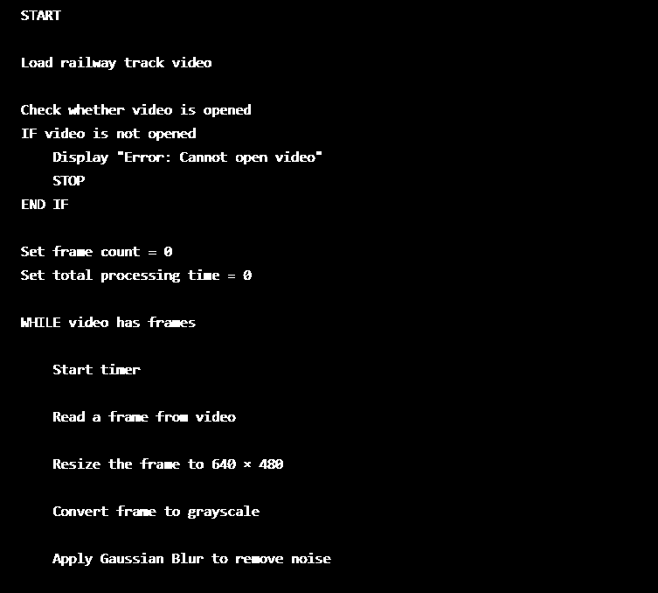
Image Processing
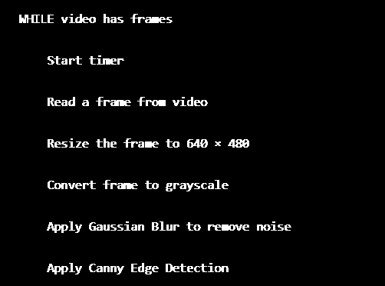

Track Detection & Display
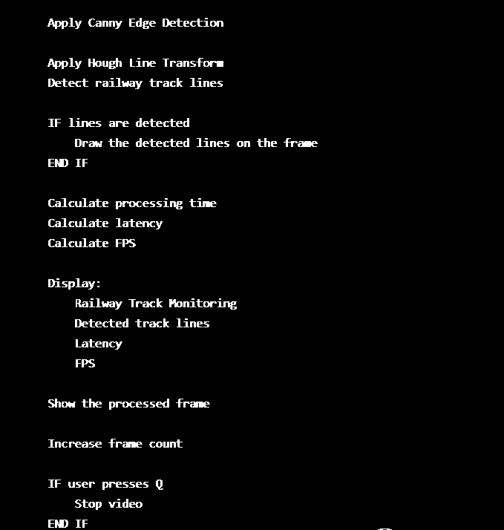
Final Performance
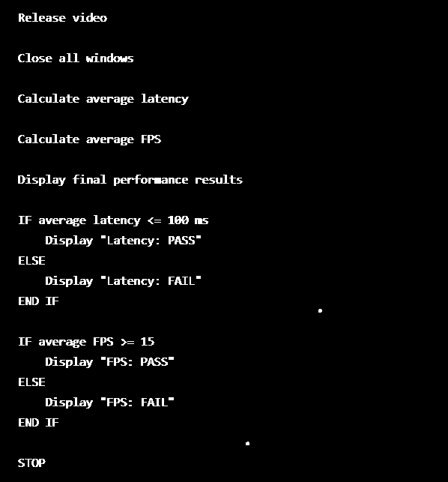

3.Implementation
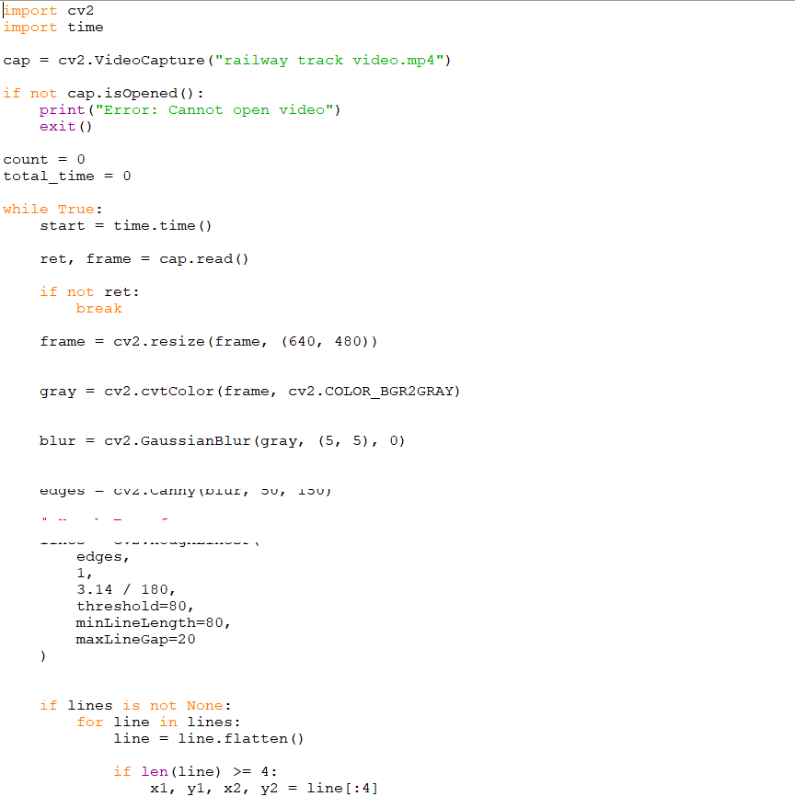
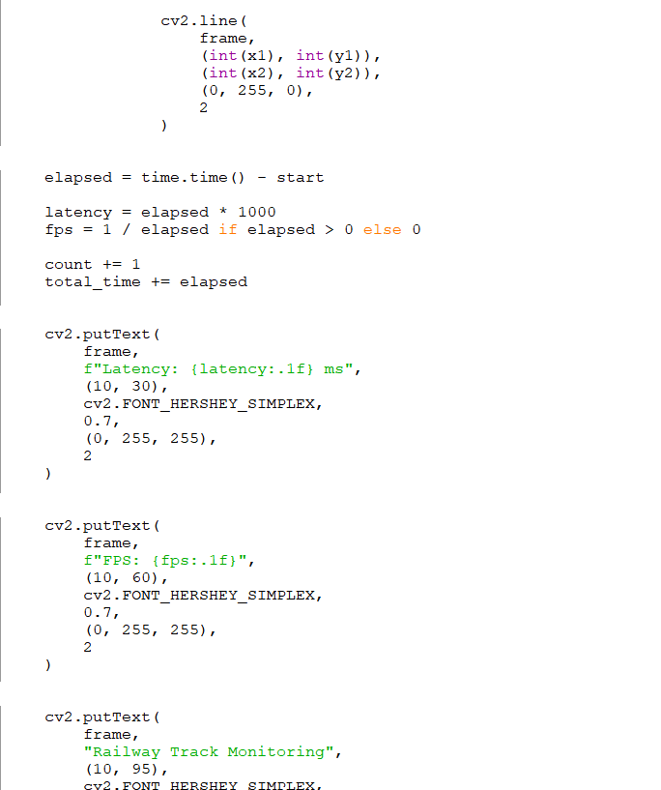

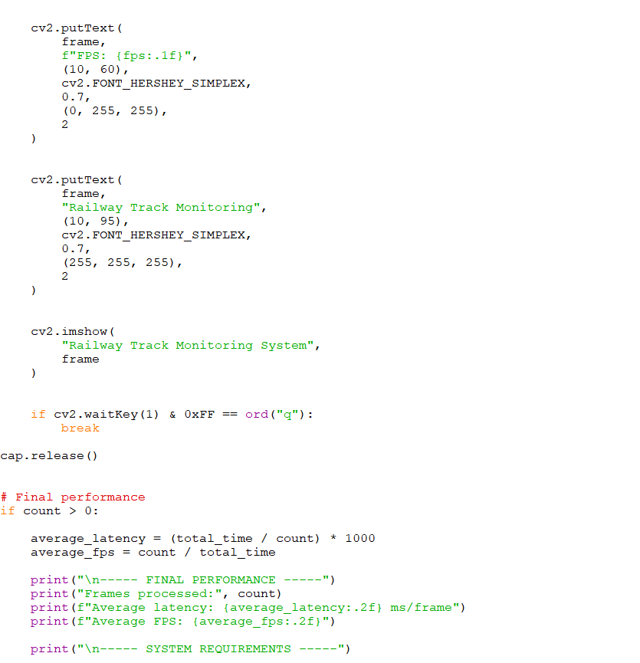
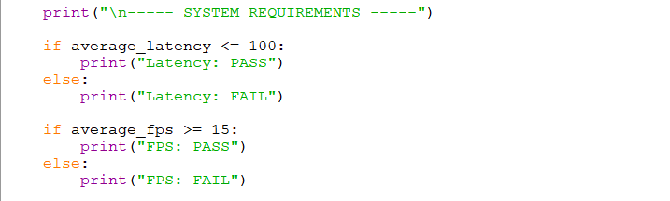

4.Output Screenshot
The figure shows the output of the proposed railway track monitoring system. Green lines represent the railway track lines detected using the Hough Transform. The system processes the video in real time and displays the latency and FPS on the screen. In this frame, the latency is 16.3 ms and the processing speed is 61.3 FPS, which satisfies the required latency (≤100 ms) and FPS (≥15) conditions.
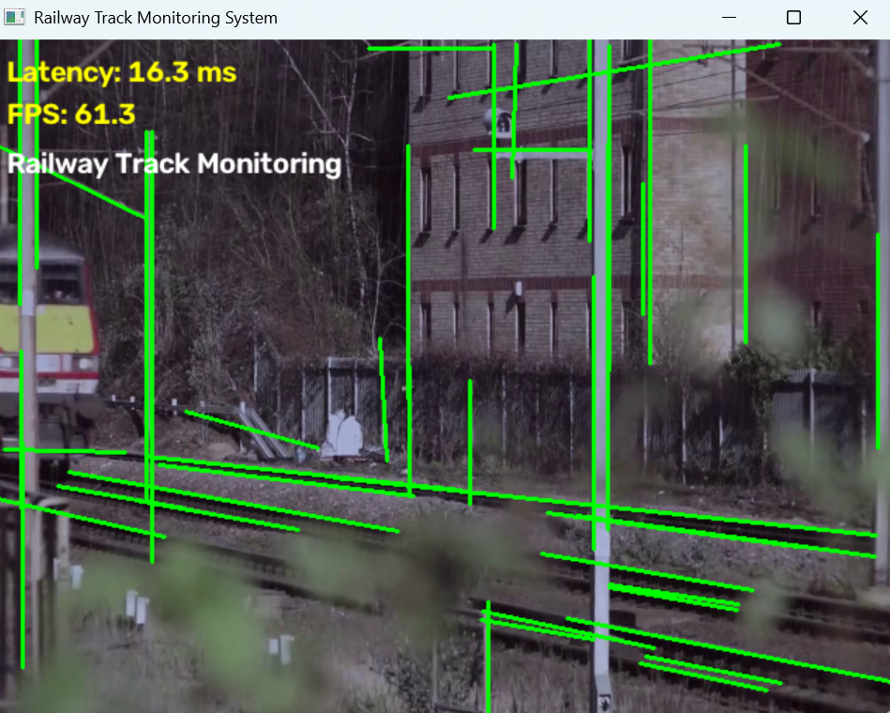

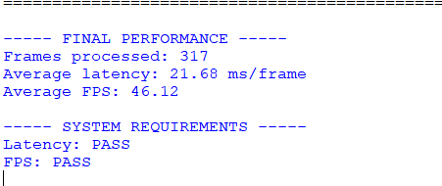

Conclusion
The proposed system provides an efficient approach for real-time railway track monitoring. OpenCV-based preprocessing and Hough Transform can effectively detect track lines while maintaining high processing speed. Based on the comparison, YOLO provides the best balance between accuracy, latency, and computational requirements. The system achieves the required performance targets in the given evaluation, making it suitable for further development and edge-device deployment. However, extensive testing with different environmental conditions and railway defects is required before practical safety-critical deployment.
Summary
The Railway Track Monitoring System is a real-time computer vision system designed to monitor railway tracks using cameras mounted on inspection vehicles. It uses image processing techniques such as grayscale conversion, Gaussian filtering, Canny edge detection, and Hough Transform to identify railway track lines. Different approaches including Edge + Hough Transform, SIFT, Viola–Jones, YOLO, and Deep Learning were compared based on accuracy, latency, and computational requirements. YOLO was selected as the most suitable approach because it provides 94% accuracy with 85 ms latency and moderate computation.

